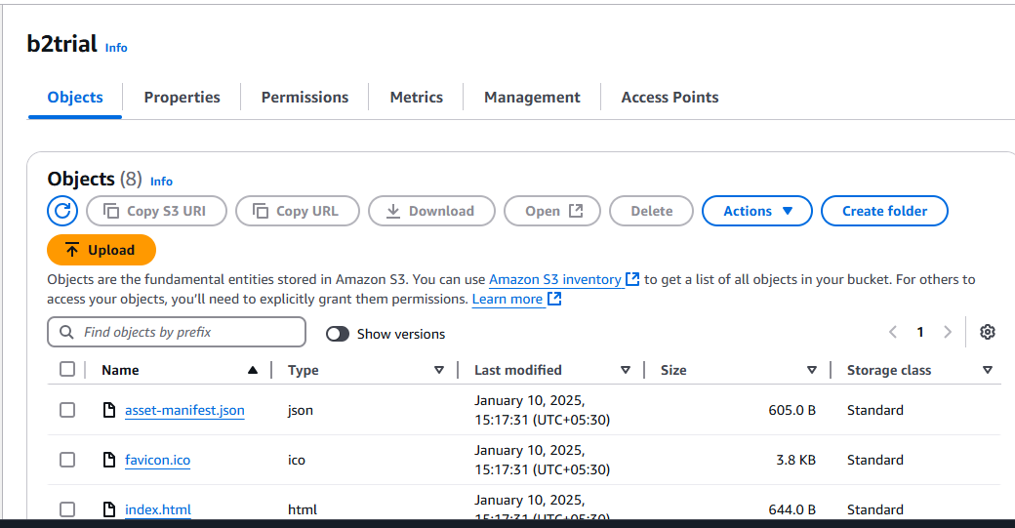

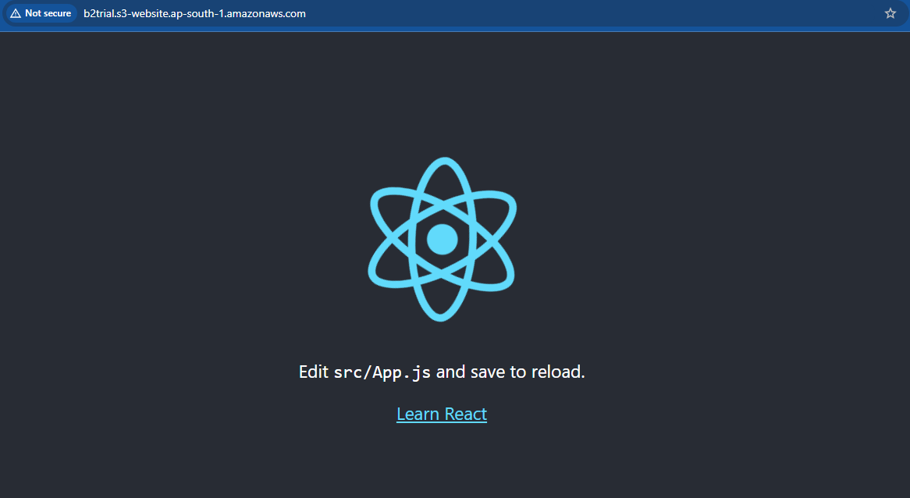

Run the command: npm run build

Then after we get build folder. Store the documents in s3 bucket which is present in build folder

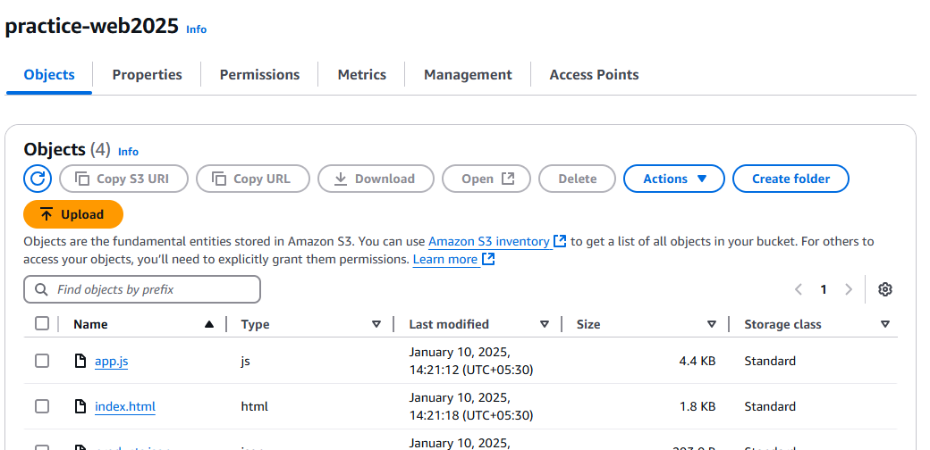

http://practice-web2025.s3-website.ap-south-1.amazonaws.com/

